**Machine Learning Project Documentation**

**World Happiness Report**

**Model Refinement**

**1. Overview**

The World Happiness Report is a landmark survey of the state of global happiness. The report continues to gain global recognition as governments, organizations and civil society increasingly use happiness indicators to inform their policy-making decisions. Leading experts across fields – economics, psychology, survey analysis, national statistics, health, public policy and more – describe how measurements of well-being can be used effectively to assess the progress of nations. The reports review the state of happiness in the world today and show how the new science of happiness explains personal and national variations in happiness.

**2. Model Evaluation**

In the initial model evaluation, results have been observed. however, areas for improvement were identified. Key metrics, such as Mean absolute error, Root squared error etc… along with visualizations from the Decision tree, Random Forest, K Nearest Neighbor steps, guided the focus on refining specific aspects of the model.

**3. Refinement Techniques & Hyperparameter Tuning**

I have used many algorithms or model such as K Nearest Neighbor, Decision Tree, Random Forest and SVM to train and test this model and also predict the future data, also I have founded Mean absolute error in every algorithm or model.

**5. Cross-Validation**

I will use GridSearchCV to cross validate model and the default bagging which is Kfold, also I will tune "cv" parameter and use the best one. Obviously, I will take model with best parameters.

**Test Submission**

**1. Overview**

The Test Submission phase involves preparing the model for deployment or evaluation on a test dataset, marking a crucial step toward finding The Most Generous and The Most Ungenerous Countries.

**2. Data Preparation for Testing**

The test dataset was accurately prepared to ensure alignment with real-world scenarios. Considerations were made to account for potential variations and challenges that may be encountered in practice. The same data preparation techniques for training data done for testing as well; missing data check









**3. Model Application & Code Implementation**

The trained model was applied to the test dataset using the best practices established during the refinement phase. The application process was streamlined to ensure efficiency and accuracy.

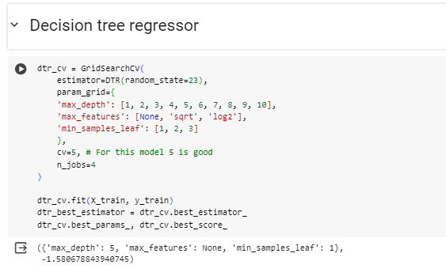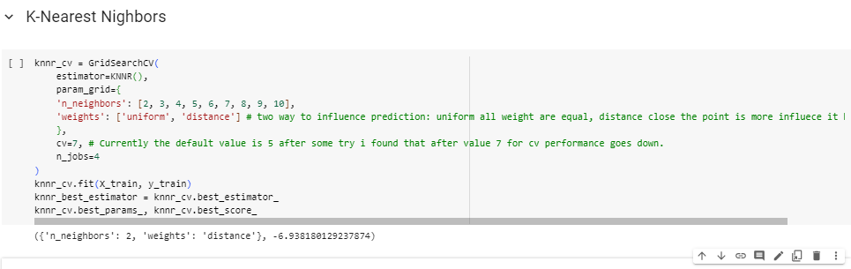

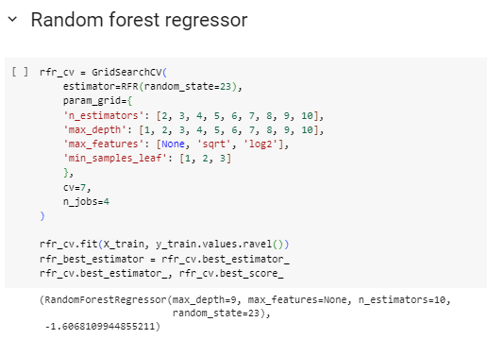

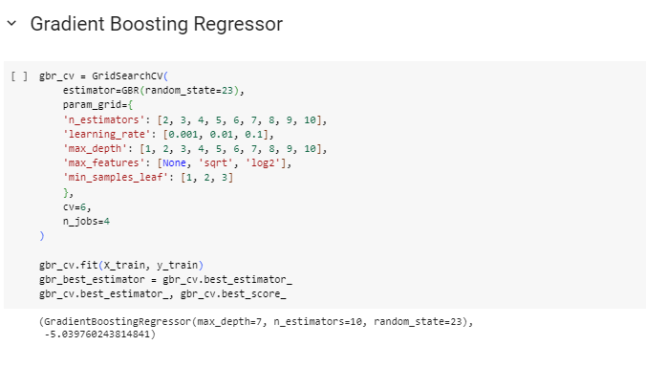

**4. Test Metrics**

Evaluation, were employed to assess the model's performance on the test dataset. For linear regression only MSE metric and for other algorithms mean absolute error metric have been done.

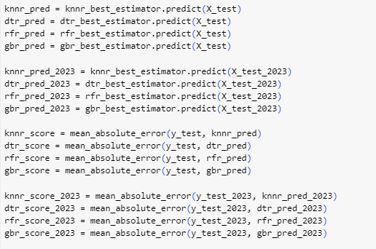

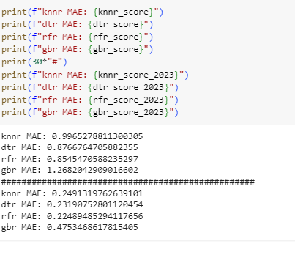

**5. Model Deployment**

Regarding deploying the model in the real-world I am planning to **use Flask or Django** frameworksand **Streamlit**. The plan is to create a user interface where users can saw the percentage of happiness in every year for different countries that system will provide it. Additionally, suggestions for facility improvement will be presented based on the model's insights. Integration with other systems or platforms was explored for future implementation.

**Conclusion**

From analyzings the data above, the most important factors in the Happiness Score of a Country are Social Support and GDP. The wealth of a country also suggests correlation to higher scores in other factors such as the life expectancy and social support. However, it is important to note that correlation is not causation, but it can provide important information for governments to understand which factors are important to the well-being of their citizens.